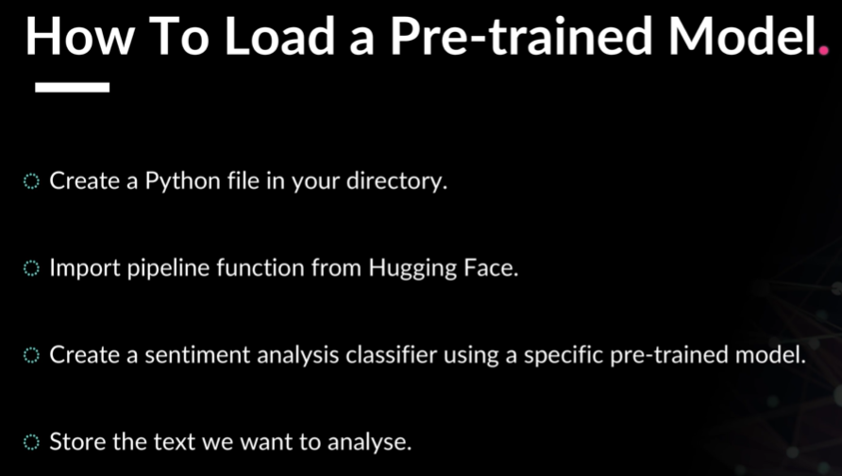

Instructions: How to load a pre-trained model
- Create a Python file in your directory
- Import the pipeline function from Hugging Face
- Create a sentiment analysis classifier using a specific pre-trained model
- Store the text we want to analyse



Create a file called sentiment_analyzer.py:

from transformers import pipeline
import pandas as pd

# Load a pre-trained sentiment analysis model
classifier = pipeline("sentiment-analysis",
model="distilbert-base-uncased-finetuned-sst-2-english")

# Test it with a simple example
text = "This movie was absolutely fantastic! I loved every minute."
result = classifier(text)
print(f"Text: {text}")
print(f"Result: {result}")

Run it:

python sentiment_analyzer.py

You should see output like: [{'label': 'POSITIVE', 'score': 0.9998}]

